RENEWAL OF WEALDSTONE SELECTIVE LICENCING

Introduction

What is Selective Licensing

Part 3 of the Housing Act 2004 (the Act) sets out the scheme for licensing private rented properties in a local housing authority area. Under section 80 of the Act a local housing authority can designate the whole or any part or parts of its area as subject to selective licensing.

Where a selective licensing designation is made it applies to privately rented property in the area. Subject to certain exemptions specified in the Selective licensing of Houses (Specified Exemptions)(England) Order 20062 , all properties in the private rented sector which are let or occupied under a licence, are required to be licensed by the local housing authority, unless the property is a House in Multiple Occupation and is required to be licensed under Part 2 of the Act .

What area can be designated

The Housing Act 2004, Part III, allows Local Authorities to introduce a Selective Licensing Scheme if certain conditions are met for the area. The Department for Communities and Local Government “Selective Licensing in the Private Rented Sector” Guide for Local Authorities states that the area must have one or more of the following being experienced:

    - low housing demand (not applicable in Wealdstone),
    - significant and persistent problem caused by anti-social behaviour (ASB),
    - poor property conditions,
    - high levels of migration,
    - high level of deprivation
    - high levels of crime

Any such designation lasts for a maximum 5 years before it is ended or goes through further consultation to be renewed. The Government Guidance around this can be found at Selective licensing in the private rented sector: a guide for local authorities - GOV.UK (www.gov.uk)

What areas have been designated in Harrow

A project was set up in 2012-13 to identify areas within the Borough that were suffering from high levels of anti-social behaviour and environmental issues. This included using data held on the private rented sector, including council tax data.

As a result, three areas were identified that suffered from a high levels of issues, which included Wealdstone, which showed above Borough average rates for serious crime and ASB, high levels of fly-tipping and a large volume of noise nuisance (especially from private rented properties). Therefore in 2016, after consultation and approval by the Council, the ward of Wealdstone became a designated area
What has happened since Selective Licensing was Introduced in Wealdstone

Since June 2016, the Council has sort to licence all rented accommodation in the designated area to ensure they are all subject to conditions specific to ensuring safety, addressing the issues found in the area (e.g. waste disposal condition aimed at reducing fly tipping) and carrying out inspections to ensure the premises are fit for habitation and safe

As mentioned above, there are exemptions to premises including those owned by Housing Associations. But to give a context of what has been licensed in this period, the 2013 census of Wealdstone showed there were 1045 rented premises in the ward. 774 (74%) have been licensed under the Selective Licensing Scheme, and 331 (31%) Houses in Multiple Occupation (HMO) licensing schemes. As can be seen, this is 60 (5%) premises more than what was captured in the original census, and is a result of premises changing use as well as some premises moving from a selective licence requirement (e.g. a single family rented property) to a HMO requirement (e.g. multiple households moving in).

What has been the effect

Data for the period 2012-13 and addresses were cross-referenced with council tax data to determined 53% of ASB and housing related complaints related to private rented properties in Wealdstone. Government census data shows Wealdstone to have 3882 households of which 26.92% are private rented. This is above the average for Harrow (21.74%). One of the requirements of the DCLG guidance on Selective Licensing is to show an area has a high proportion of private rented sector, with anything above the national average of 19% meeting this criterion.

Anti-Social Behaviour and Crime

In 2015, Wealdstone Ward has had Anti-Social Behaviour designated as a priority due to it being the biggest crime issue for the Ward as can be seen in the table below:
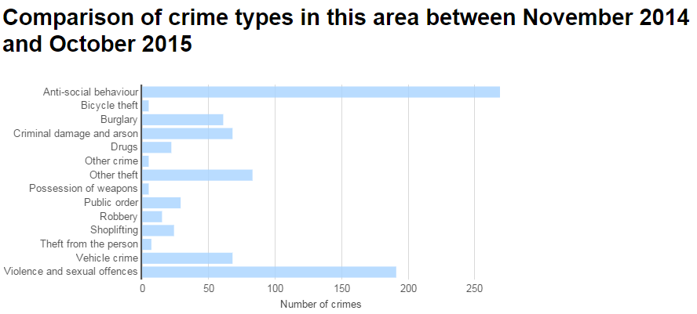

From December 2019 to November 2020, these figures are now:

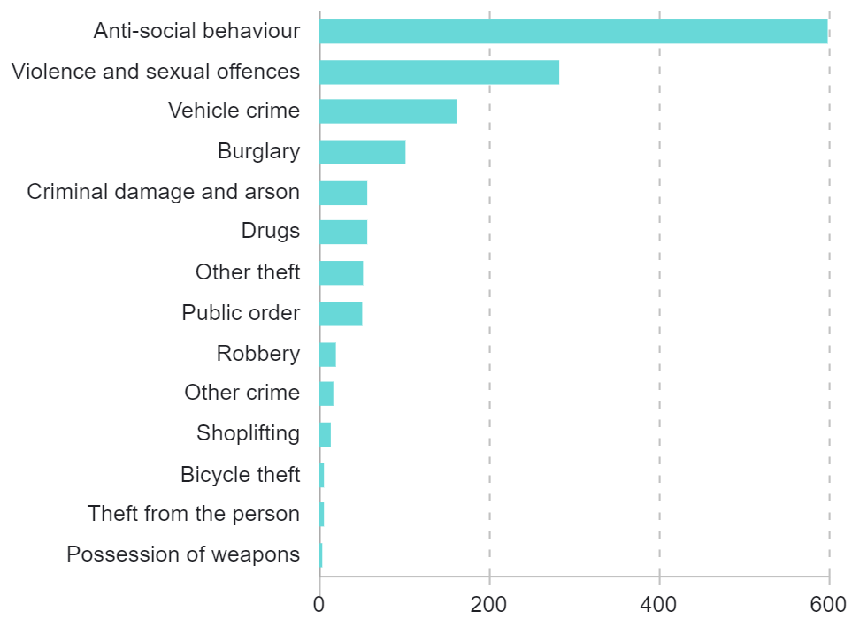

Anti-Social Behaviour accounted for 31.57% of all crime types over the period November 2014 to October 2015 but from December 2019 to November 202 accounted for 41.6% in Wealdstone Ward. Unfortunately, while ASB therefore remains a big concern in Wealdstone, these figures do not give a true reflection of the situation due to the covid-19 pandemic leading to gatherings, lack of social distancing and people refusing to comply with the covid-19 requirements being reported as ASB which has led to a very large increase.

This is evidenced by neighbouring wards including Marlborough (28.29% in 2015 to 48.8% now), and Harrow Weald (27.33% to 30.6%)

But the vitality profile for wards from 2015-2017 show that Wealdstone is improving across key areas such as burglaries, deliberate fires and general crime

And across key aspects selective licensing addresses, or seeks to address, being fly tipping and noise, Wealdstone has seen gradual improvements. The 2019 vitality profile shows a clear reduction of these areas with fly tipping clearly reduced in Edgware (Selective Licensing introduced in 2015) and Wealdstone (2016)

Migration and Deprivation

Government census data also shows that Wealdstone Ward has a high level of migrant population, accounting for 46.86% of the population. This includes high levels of transient population in the ward, which can have a direct effect on the economic stability of an area. This is recognised in the DCLG Guidance.

At the time of selective being introduced in Wealdstone Ward is one of the smallest wards in Harrow, but is the densest in terms of population, with 96 persons per hectare compared to a Harrow average of 47.4pph. The population of Wealdstone Ward has increased by 27.1% in the last 10 years which has added to this issue. This is compared to around 13% increase in population in Greater London in the same period.

The average household size in Wealdstone is 2.93 compared to a Harrow Borough average of 2.81. Due to the increase in size of population and relatively high level of occupancy levels, there are tangible concerns over properties becoming overcrowded. This is a consideration under the DCLG Guidance.

In 2015, the CLG indices of deprivation show that Wealdstone is the Ward with the highest level of multiple deprivation, followed by Roxbourne, Greenhill and Marlborough. It has the highest levels deprivation of the Borough around income, education, skills, training and employment. In terms of Income Deprivation Domain, being the proportion of people aged under 60 in an area that are living in low income households and claiming certain out-of-work means tested benefits, Wealdstone Ward is the most deprived Ward in the Borough.

In 2019, Wealdstone remains the ward with the highest level of multiple deprivation, followed by Roxbourne, Greenhill and Marlborough But it did witness improvements to income deprivation (0.2 to 0.16), Income deprivation of children (0.28 to 0.18) and employment deprivation (0.12 to 0.09). Overall this indicates that the area is improving in terms of being less deprived, though obviously more work is needed as it continues to be at the, or near the, bottom of the deprivation indices.

Consistent with Housing Strategy

Selective Licensing ties in with the Council’s Private Sector Housing Strategy for 2019-2024, using additional powers to address areas where private sector housing can be seen to contribute to issues faced in the community and need addressing. It is to work with good landlords to provide them the environment where these properties will be successful and can be managed successfully.

Co-ordinated Approach

Government Guidance clearly sets out that “Selective licensing is not a tool that can be used in isolation. The local housing authority will have to show how such a designation will be part of the overall strategic borough wide approach”

ASB

The aspect of Selective Licensing is just one aspect of the Public Protection Service, who also oversees the Anti-Social Behaviour Team, inspection of private rented accommodation and enforcement of environmental issues (e.g. fly tipping caused by persons including tenants). This team also liaises with the Council Housing Anti-Social Behaviour element to ensure a consistent approach to issues.

The Anti-Social Behaviour, Crime and Disorder Act 2014 introduced new powers that can be used to address issues of ASB, including absolute grounds for possession as well as conduct causing nuisance to landlord etc. These powers, as well as those considered under Section 2 (Options considered) will be used in parallel with any Selective Licensing Scheme to improve an area.

Since 2015, the Council has introduced Public Spaces Protection Orders to address street drinking as well as other anti-social activity that blights Wealdstone in particular. It has carried out numerous days of action between Council enforcement and Police, as well as put in place a Wealdstone Action Group to get the community involved in improving the area, with regular community meetings

Homelessness and Property Standards

By having a well-managed private rented sector, it is more likely to have increased residential stock of suitable standard for the purposes of addressing homelessness and emergency accommodation. The improvement of this sector is also likely to increase demand of housing and attract good landlords to an area, which will hopefully encourage the bringing back into use of any empty homes.

Harrow has endeavoured to inspect all premises that fall under the Selective Licensing scheme to assess them under the Housing Health and Safety Rating Scheme, to ensure they are safe for habitation and meet at the very least basic needs.

Other Approaches

HMO Licensing

HMO licensing refers to the licensing of Houses in Multiple Occupation (HMO) where the premises is occupied two or more households. This licensing regime has been in place in Harrow since 2006, and certain discretionary aspects will continued to be renewed where there is evidence of need.

This approach is still being taken, but as can be seen this only accounts for about 1 in 3 rented premises in Wealdstone.

Borough Wide Designation under Selective Licensing

Some councils have adopted Borough Wide schemes, such as seen in Newham, but Harrow has been keen to ensure that such a scheme is used only where it is required for a targeted approach, and in line with legal requirements. Additionally, it is important that there is a clear evidence base to support any scheme, and for the areas proposed, which is established for Wealdstone but is currently not in place for the whole Borough.

Accredited Landlord Scheme

There are accredited landlord schemes in operation that put in place a consistent standard and lead to improved standards of accommodation, but not necessarily matters of ASB. While such schemes are valuable, it is imperative that all landlords in an area engage in improving it. Such a scheme is voluntary and so take up is variable. Therefore it is felt that a more intensive intervention is required, making it mandatory on all landlords to comply with conditions in order to address the problems being experienced in the area. This option is already in place, but merely complements licensing and does not address the wider issues that selective licensing is expected to help with.

Action against Individual Cases

Legislation allows enforcement action to be taken against cases of nuisance and fly tipping (Environmental Protection Act 1990), Anti-Social Behaviour (ASB, Crime and Policing Act 2014) and other related matters

The Council has introduced Fixed Penalty Notices for environmental issues, such as littering across the Borough

The Anti-Social Behaviour, Crime and Policing Act 2014 also introduced additional powers to local housing authorities by way of absolute grounds for possession in housing cases where certain conditions are met, although this will only assist with council tenancies.

But these only address a problem at a time rather than addressing the bigger issues in an area and fundamentally change culture and behaviours. Where individuals do warrant it, the Council will take action using all tools available.

Special Interim Management Order

A Special Interim Management Order transfers the management of a residential property to the local housing authority for a period of up to 12 months and can only be made if approved by a residential property tribunal.

These orders are used to address matters of anti-social behaviour emanating from a property that the landlord is failing to take appropriate action to deal with. The order is then made to protect the health, safety or welfare of persons occupying, visiting or engaged in lawful activities in the locality of the house.

These are strong powers to deal with isolated individual problems of individual anti-social behaviour which nevertheless seriously impact upon the community.

This option is already in place, but has localised effect on its own and can be used where a focused approach is needed.

Part 1 of the Housing Act 2004

These enforcement powers are designed to effectively deal with hazards within a property and though effective at getting landlords to remedy such hazards, Part 1 of the Act does not offer a wider strategic procedure to improve a designated area.

Empty Property Strategy

The council already has an intervention team dedicated to bringing long-term empty dwellings back into use but this initiative is only restricted to empty homes and cannot deal with poorly managed private rented accommodation.

So has the scheme been successful and why should it be renewed

In 2015, the Council set out some key aims it hoped to achieve under the Selective Licensing scheme being a reduction of

- Accumulation of waste
- Drug and alcohol related crime
- Gang nuisance
- Illegal conversions
- Negativity due to badly managed and poorly maintained properties
- Overcrowding
- Sub-letting
- Vandalism
- Transient population, leading to a more stable community

In simple numbers, the scheme has been a success in terms of premises licensed and, as a result of that, being raised in terms of management and standards based on inspections conducted and conditions imposed.

An analysis of enforcement cases since 2015 also shows the issues occurring in Wealdstone:

Description | 2015 | 2016 | 2017 | 2018 | 2019 | 2020 | Change
Abandoned vehicle report | 55 | 125 | 81 | 88 | 29 | 29 | ê
Drug substance misuse dealing | 2 | 3 | 3 | 3 | 7 | 8 | é
Flytip small - council | 70 | 66 | 83 | 129 | 20 | 22 | ê
Housing Dampness | 5 | 8 | 12 | 12 | 2 | 2 | ê
Housing Disrepair | 14 | 18 | 25 | 49 | 9 | 10 | ê
Housing Overcrowding | 3 | 2 | 4 | 13 | 1 | 1 | ê
Intimidation or harassment | 1 |  | 2 | 3 | 2 | 2 | é
Noise | 39 | 57 | 58 | 101 | 29 | 31 | ê
Nuisance behaviour | 3 | 7 | 10 | 12 | 16 | 17 | é
Vehicle noise or use (ASB) | 1 | 2 | 4 | 3 | 3 | 3 | é

What this shows is that when the scheme came in numbers across all areas started to increase as awareness and a proactive approach was taken to the area, but then in the main start to fall as the scheme in-bed in the area especially those linked to accommodation and people within (noise, fly tip waste, disrepair, dampness, overcrowding)

The evidence does show that Wealdstone is getting better in the areas that Selective Licensing directly impacts. But it also shows that, combined with the deprivation and ASB aspects, there is still more work to be done. And it is likely that this is more around those premises that have remained under the radar and now need to be tackled directly. Over the last 5 years, there have been 126 reports of suspected selective premises in Wealdstone, but 101 of these in the last 2 years as awareness increases including the register of licensed premises on the Councils website.

Therefore the Council is seeking to renew the scheme to continue these improvements, working with those who have licensed previously to ensure conditions are being met, and targeting those that become more obvious as their management of their premises makes them stand out through complaints.

But it is important to get the views of all to ensure that this is supported and that any improvements, amendments or changes that would further improve this area are highlighted and raised.

Police.uk
crime (harrow.gov.uk)
environment (harrow.gov.uk)
http://www.harrow.gov.uk/download/downloads/id/2017/2011_census_briefing_note_13
http://www.harrow.gov.uk/download/downloads/id/3791/2011_2013_deprivation
deprivation (harrow.gov.uk)

